Abhiyan Dahal

Student ID: 220107

1. 1)Write a menu driven program for addition, subtraction, multiplication and division using function and case statements.

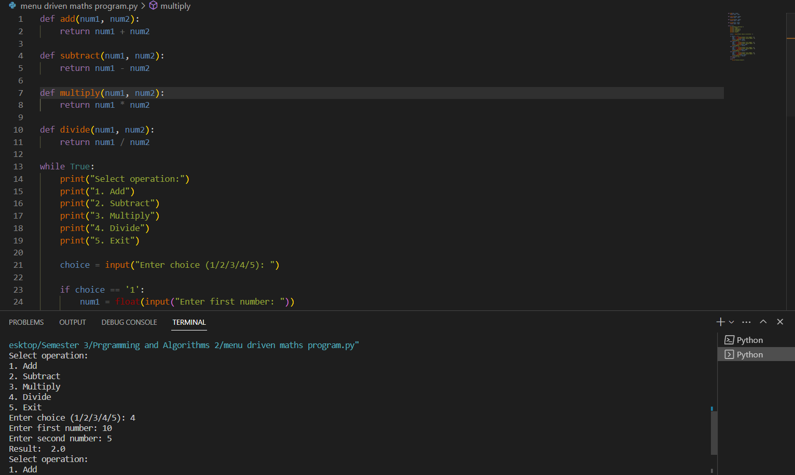

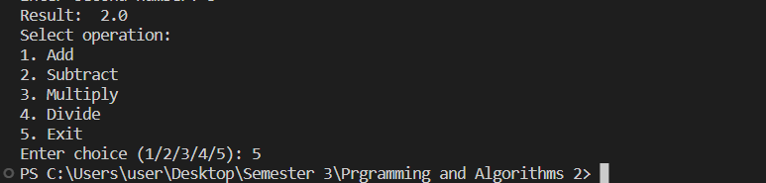

1. Write a menu driven program for finding maximum and minimum between any two numbers; maximum and minimum among three numbers.

Maximum and minimum between two numbers:

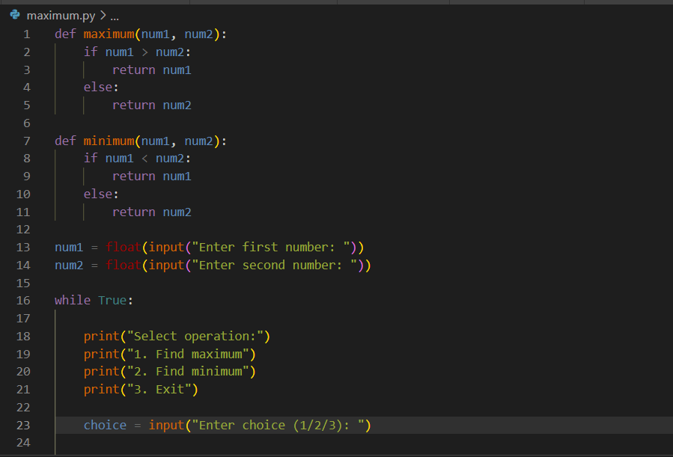

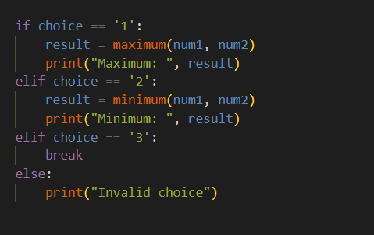

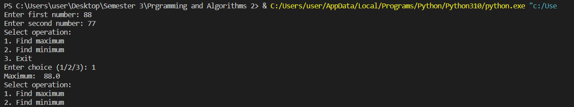

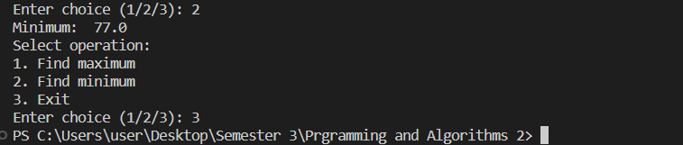

Maximum and minimum between three numbers:

